Project Planning

The steps to planning your project successfully.

# Define ...your Project

What is an appropriate capstone project?

* What is a “business problem” that you want to solve? Do you have anything in your personal life that frustrates you that you could see an app solving in some way?
* Do you have a business yourself that you could see an app solving a business problem you have?
* Do you have a friend or someone you know with a business that could use an app to solve a business problem?
* Do you have a product or a service that you would like to create an app for and build a web presence? Ecommerce site?
* Do research on other websites – Google to see if someone has already made an application based on your idea – pick it apart to see what you like – do not like and how you can make it better.

**Capstone Project Guidelines:**

* Students must complete and effectively present a capstone project. Said project will meet the following general requirements
* Display an effective approach to the project-planning process. This includes wireframing, UX/UI design, Trello boards, etc.
* Display an understanding of semantic HTML and modern CSS approaches.
* Render as a Single Page Application using a ‘state’ object and a ‘render’ function to display ‘views.’
* Log a sensical, well-organized ‘commit’ history.
* Use an external API to send/receive data and update Single Page Application views accordingly.
* Incorporate a back end – Node.JS / Express.JS/ PostgreSQL
* Deploy to Heroku

“Why manufacture a car with an expensive paint job without an engine? Consider your audience, do they want you to build static web pages or an application that solves a problem or accomplishes a task?”

* Should display your development skills and creativity in a professional manner.
* Can be completed in the allotted time frame you have to commit.

# Define ...your Audience

Who is the target audience for the capstone project? Do research!

* It's not you!
* Mentors & Peers
* Recruiters & Career Coaches
* Hiring Managers
* Ultimately the consumer of your product
  + How is your idea different, better, define your audience and run your ideas by them to get feedback on what they would like to see in an application? Document their feedback and keep that in mind / refer to as your building out your application.

# Determine … what YOUR project will be.

Create a high-level story you want tell with your project.

* This will be your elevator pitch for your capstone project and used during demo day.
* Allows users to ask questions via chat during a talk and add resources to videos. "
* "I want to create a web APPLICATION that...

# Define ...your Content

Determine what pages you need and the content of each page.

Don't worry about look and feel or style of the content, that comes later.

1. Make a list of pages
2. Write a brief description of the content for each page
3. Navigation
4. Main content
5. Footer

# Define ...your User Flow

What interactions will the user be required to do to use your web application. Example: E-commerce Application

* Focus on page flow not content of pages
* Make sure you analyze all user flows, creating multiple flow charts if necessary.

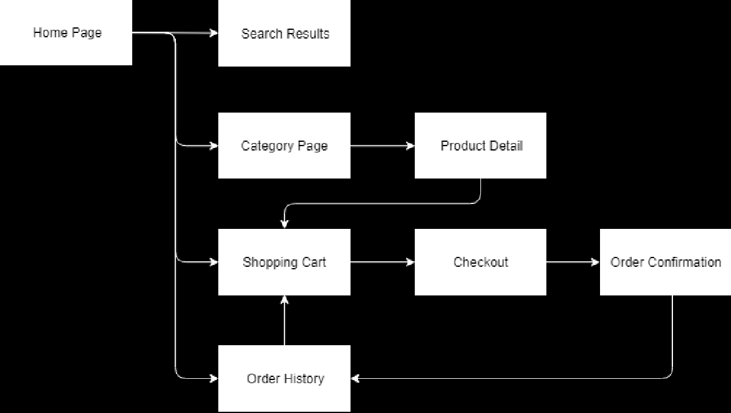

# Create ...Wireframes

Start with pencil and paper or whiteboard, then if necessary, create a digital version Analog Tools:

* Pencil & Paper
* 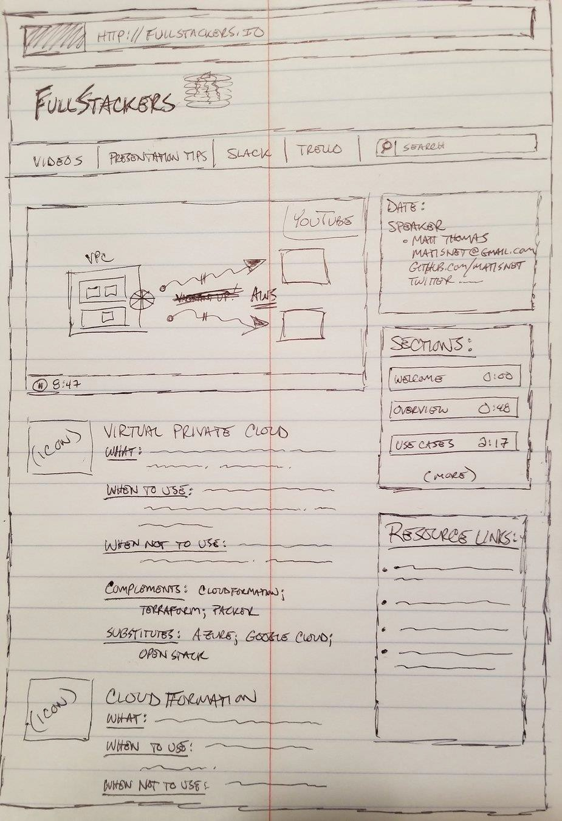Whiteboard & Dry Erase Markers

Digital Tools:

* Draw.io (https://[www.draw.io/)](http://www.draw.io/)) <- Recommend
* Adobe XD (https://[www.adobe.com/products/xd.html)](http://www.adobe.com/products/xd.html))
* Inkscape (https://inkscape.org/)
* Adobe Illustrator (https:/[/www.adobe.com/products/illustrator.html)](http://www.adobe.com/products/illustrator.html))
* Mockflow (https://mockflow.com/)
* JustInMind (https://www.justinmind.com)

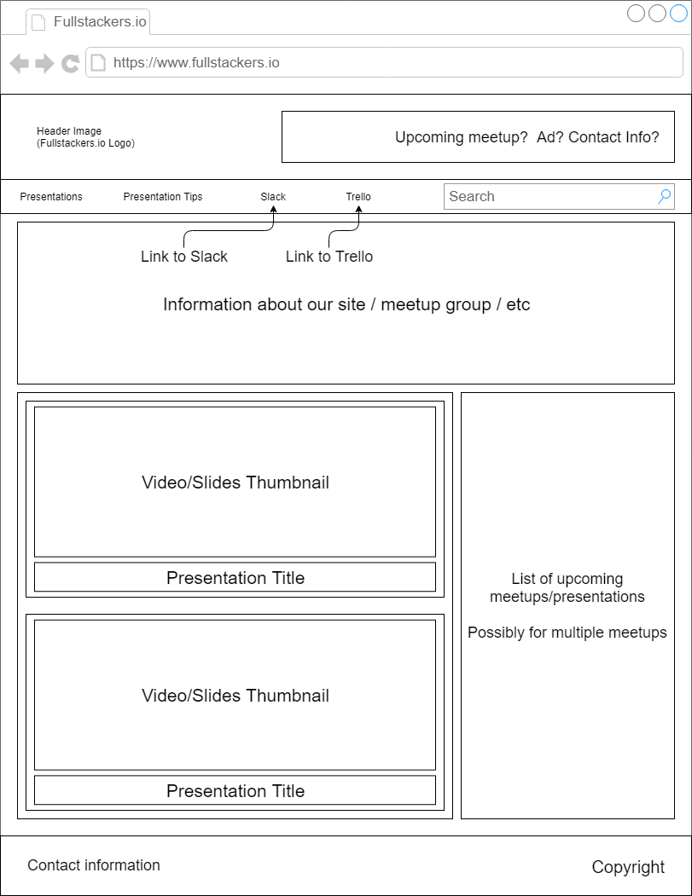

# Create ... (Homework) Documentation

1. If you have not done so yet – create an account for yourself on [www.github.com](http://www.github.com) (name should be professional)
2. Create your capstone repo (in a new folder) and add a docs folder.
3. Create a docs folder, add documentation in the form of markdown, images or PDFs.
4. Update your README.md file to link to your new project documentation.
5. Your documentation should include...
   * Definition of your audience (We already did this, correct?)
   * Definition statement (I want to create a web application that...) for your project
   * High level story (elevator pitch)
   * Outline of the content
   * User Flow
   * Wireframes (1 wireframe per page minimum, hand-drawn is ok!)

The documentation will be included in your portfolio, so make it look nice. Due next week, submit link to your repo in the Slack channel to be reviewed.

# What's Next!

* Design your Website
  + Focusing on UX and UI design
* Define a Timeline
* Create your Kanban board using Trello
  + Stories writing
  + Tasking out stories
* Test, Test and Testing